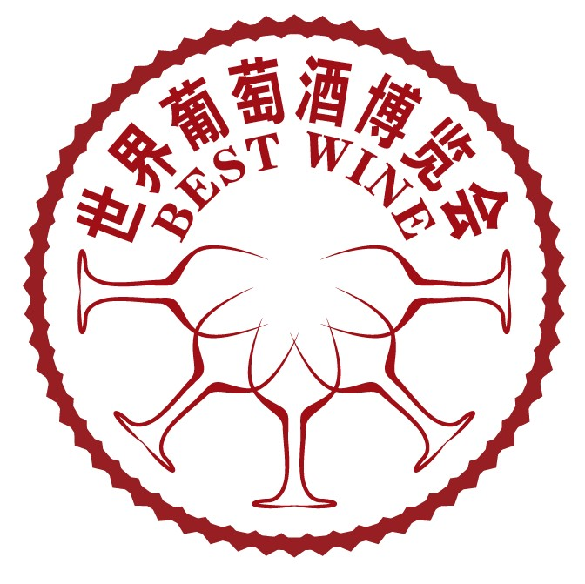Best Wine China

12th China International Wine Industry Expo, 2014
April 27-29th，2014 Everbright Convention&Exhibition Center, Shanghai
13th China International Wine Industry Expo, 2014
November 25-27th, 2014 China International Exhibition Center, Beijing
www.bestwinechina.com
Theme: "Healthy, vitality and life-stylish beverage"
Focus: Standing in Beijing, Spread to whole nation, customer value optimized, establish a perfect wine product marketing platform!
Approved by:
Ministry of Commerce of P.R.China
Sponsored by：
China Council for the Promotion of International Trade
Asia Economy Trade&Development Center
China international trade promotion association
Asia Healthcare&Nutrition Promotive Commission
Chinese liquor circulation association
Organizer:
BEIJING HAIMING HUIBO EXHIBITION CO., LTD
Co-organizers:
China Famous Wine Association
China Drinks Commission
Overseas co-organizer:
East Hong Kong International Exhibition Co., Ltd
★Supported Media
TVS： CCTV—1、CCTV—4、CCTV—7、BTV Life、BTV Comprehensive、BTV Finance、Shanghai Star TV, Money TV, CRI、CNR、Beijing Radio Transportation、Radio 103.9、Radio 959
Newspaper&Magazine：Health This Week, Beijing Evening, Beijing Daily, Beijing Morning, Beijing Messenger, People Daily, News Morning, Global Times, Yangtze Evening, Qianjiang Evening, Hongkong Takungpao, Lifestyle, Jinghua Times, Huaxia Wine, Wine Viewpoint
TV news+Ads broadcast, put building and Beijing Bus ads, cover all habitants
Websites:www.ec21.com,http://ccne.mofcom.gov.cn/,http://win.mofcom.gov.cn/en/,www.tradekey.com,
www.clocate.com,www.chinaexhibition.com,www.alibaba.com, www.eventbrite.com www.foreignercn.com www.biztradeshows.com www.expopromoter.com www.learnmorechina.com,people.com,Xinhua.net, Wine Business, cnfood.net, 21food.cn, winenice.com,wine-world.com, villas.com.cn, 9ye88.com, womai.com, hongjiu.biz, jianiang.cn, Chinawine.com, js118.com.cn, cada.cc, winechina.com, cn-ferment.com, zgnj.org, shaojiu.com, cnwinenews.com, sina.com.cn, sohu.com, www.tradeindia.com www.foodworld.com www.foodreference.com www.conferencehound.com www.tradeshowadvertiser.com www.eventseye.com Global Luxury, cngold.org, mplife.com, DUODEFU.com,neeu.com, inluxe.cn, chinasspp.com, yicai.com, asia-rich.com, QQ.COM,taobao.com,163.com, 58.com, ganji.com, baidu.com, mop.com, tianya.com, xici.com, enorth.com.cn, 72177.com, bjedu.com, real time news release everyday, wholly interact with all netizens, open communication column on websites, micro blogs on, cgcc.org.cn and other major local websites.

Experienced 10 session development:
our expo has become one of the largest wine expo in China mainland！It has started since year 2008. We have more than 60 wine relevant governmental institutes, commerce ministry, wine associations, and food associations’ organization resources as well as 600,00 buyers information! Our wine show has become an international communication platform of wine industry businessman and fans! It has obtained praise and recognization of 128 governments, chambers, associations, commercial institutes! It is a wind vane and barometer of imported wine! It has propelled wine industry quickly development!
Our achievement:
Last expo area: 12,000 ㎡, 500 Standard booths, including domestic 380 domestic and 120 international booths. There are about 8 national ministry or committee, 28 provincial(district or city) and Xinjiang Production and Construction Corp, delegates, 15 country has organized team, 8 embassies, 5 overseas provincial or state governmental representatives,158 journalists from 69 media organization has participated our expos since the first session. There are about 140,00 visitors in total. Altogether, there are 680 enterprises has attended to our expo already. 126 pieces of agreements and 36 million RMB trading amount has been reached through our expos.
Scale of this expo:
Expo area: 15,000㎡，600 standard booths，domestic booths: 420，International booths:180. International exhibitors including Ch teau Lafite Rothschil, Chateau Latour, Chateau Mouton Rothschild, Chateau Margaux, Chateau Haut Brion, Rémy Cointreau, Pernod Ricard Group, BACARDI , Brown Forman, Hennessy famous brands，worldwide top 10 spirits, red wine, beer brands gathered together here! Domestic wine brands including Moutai, Wuliangye, Shuijinfang,Xifengjiu, Gujingongjiu, Fenjiu,Yanghejiu, Daohuaxiang,Langjiu, Hongxing will participate this expo. Wine brands including Mogao, Changyu, Greatwall, Xintian, Dynasty Wine,Tsingtao,Snow Flower, Budweiser, Zhujiang Beer,Yanjing Beer will show their new products during this expo.
★Advantages
1. The government, consulates and trade association’s business leaders at the opening address.
2. North America, Europe and China’s wine market trends.
3. The history of Bordeaux, Bordeaux All in all, the French wine classification system, Bordeaux and other local cuisine.
4. The rapid growth of wine in China under the brand of choice environment.
5. China’s wine trends and forecasts; importer of high-level participation of more than discussion.
6. Special tastings, sommelier talent show.
★Exhibits
Imported wines: red wine, white wine, rose wine, ice wine, champagne, sparkling wine,porter,sherry,natural,liqueurs,vermouth,binuoliqueurs,spirits,whisky,brandy,vodka,gin,rum,agave liquor. sake, wine, beer and low alcohol drinks
Chinese Wines: white wine, beer, liqueur, yellow wine, ice wine, wine with milk, wine ,rice wine, fruit cordial, health wine
3. Wine Equipments: wine cellar, wine tools, wine drinking vessel, wine packaging and storage technologies, wine culture books, wine pictures, wine extensions,
★ Visitors:
1. The wine industry, traders and retailers: importers, wholesalers, sales representatives, specialty retailers, professional chain of retail stores.
2. Cafés, hotels and restaurants: major hotels and night clubs and (food and beverage managers, sommeliers), chain restaurants and chain hotels.
3. Clubs, apartments, resorts, clubs, KTV, sauna bath, bar, bath / foot center, SPA.
4. Large supermarkets and ordinary supermarkets: supermarkets and ordinary supermarket purchasing centers drink purchasing manager, manager of the wine industry.
5. Sommeliers, bartenders, wine appraisers, Chinese and Western chefs, snacks division, Western-style pastry, sweets production division, gourmet and so on.
6. Duty-free shops, luxury car owners, owners of luxury cars, top real estate owners, villas, luxury real estate owners, major luxury.
7. The brand VIP customers, the Bank’s International Bank VIP clients, insurance companies, VIP clients, securities companies VIP customers.
8. Foreign embassies and consulates in Shanghai institutions and corporate representatives.
9. Enterprises, business elite, white-collar workers, senior managers, government agencies and some lineup.
Participation Procedure:
1. Exhibitors must have valid "hygienic license", "business license" and "products approval documents";
2. Exhibitors should firstly contact the organizing committee to choose their ideal booth position, and then fill in the exhibition application form and agreement form. Mail or fax the forms with your signatures to the organizing committee. This contract will be effective after being signed by both parties. Faxes or copies are valid.
3. Booth Distribution Principle: Paid first, served first.
4. According to the venue and security needs, the organizer has the right to adjust some confirmed booth.
Expo Activity Series:
“International Expo China Cup, International Expo Gold Cup, International Expo Crystal Cup” （Only 1 cup for each kind of products）
We will invite experts, scholars, authorities, collectors, international and domestic sommeliers form a selection committee to select right products among all participated products. Those which are interested in awards selection please apply for awards according to “Awards Selection Requirements” and send necessary documents and materials to Awards Selection Committee before the date of April 10th, 2014. The result will be informed to the related enterprise before opening of expo. The ceremony will be held on the expo opening. We will invite CCTV, BTV and other media report and interview the winners. Winners will be invited to Wine Summit Forum and meet with celebrities and other activities. Experts will state” safe brandy wines, China Brands and National Spirits”.

Through the efforts by sponsors, organizers and supporters, our exhibition will be very professional and provide you an international commercialized environment. So, we believe no matter what kind of booth you have, you will benefit on the participation to our exhibition.
The business opportunities for being a sponsor:
1. Sponsor company will enjoy propaganda with the various exhibition advertisements;
2. Enjoy all kinds of advertisements during the exhibition spot;
3. with reasonable investment to get unlimited advertisement effect.
If you would like to become one of our sponsors, you would enjoy the following benefits from us:
1. Special treatment
2. Propagandize on the opening ceremony
3. Advertisement during the exhibition
4. Invitation of the professional visitors’ advertisement
5. Catalog advertisement
6. Web promotion
7. Media promotion
8. Forum
9. Invitation Ticket advertisement
10. The best booths
About the details, please consult the organizing committee.

Price List
I: Booth Price
Area | Dimension | Fee | Raw Space only | Fee
Area T(Luxury Booth) | 3m×3m | USD4,800 | Area T | USD420/M²
Area T(Standard Booth) | 3m×3m | USD4,200 | Area T | USD420/M²
Area A(Standard Booth) | 3m×3m | USD3,800 | Area A | USD380/M²
Notes:
A.10% surcharge for two opening booth；B. Facilities：9㎡exhibition space, wine tools and ice 2.5m wallboard, lintel plate, a desk, two chairs, a 220V power socket, two daylight lamps, security and cleaning service；C. Raw space only (area) Fee includes：exhibition space, security and cleaning service; D.36㎡ is the baseline to rent as raw space，not including the installation fee, E. Raw Space position is better than Area Luxury Booth Position, Luxury booth position is better than Standard booth position, Area T is better than Area A F. Booth arranges order: paid first, served first.

II：Advertisement Price
Catalog Cover | Catalog  Back Cover | Color Page  Spread | Catalog Cover  (the second, third page) | Color Pages inside of Catalog | Black and white Pages of Catalog
USD2,700 | USD2,200 | USD1,500 | USD1,800 | USD750 | USD300
Ticket | Invitation Letter | Visit Ticket | Handbag | Stair Banner | Pillar(40)
USD750/10,000pcs | USD750/1,000pcs | USD1,250/10,000pcs | USD750/1,000pcs | USD300/1piece | USD2,950/40pcs
Balloon (Diameter 3m)  Banner 15mX1.4m | Lantern (Diameter5m)  Banner 15mX1.4m | Rome Pillar Banner 20mX10m | Wall Banner  24mx3m | Flag  1.5mx0.45m
USD1,200 /piece | USD1,800/piece | USD3,700/Group | USD2,700/piece | USD50/1

III. Forum Price
Forum | Within 3 hours(half a day) | USD3500 | Free service:  1.A conference hall for more than 150 people;  2.Power socket, projector, stereo, microphone;  3.Guide in the exhibition center and Ads board position;  4.Broadcasting service and audience organization;
Forum | Within 2 hours | USD2500
Technology communication | Within 1 hour | USD1500
Attract investment | Within 1 hour | USD1500
Products Introduction | Within half an hour | USD1500

Project Manager: Smith Song

BEIJING HAIMING HUIBO EXHIBITION CO., LTD
Add: Room 1801, Building 5, Jinhaiguoji Center, Guangqu Road No.21, Chaoyang District, Beijing, P.R.China. 100124
Tel: +86-10-59572664
Mobile: +86-15712956058
Fax: +86-10-58850889
Skype: cowboysmith
Email&MSN: songxq123@hotmail.com

