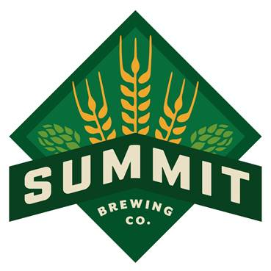
CONTACT: Carey Matthews
Summit Brewing Company
(651) 265-7821
cmatthews@summitbrewing.com

FOR IMMEDIATE RELEASE

Summit releases English-Style Barleywine Ale
to close out 30th Anniversary Beer Series.
ST. PAUL, Minn. (November 8, 2016) – Summit Brewing Company announces the release of 30th Anniversary English-Style Barleywine Ale, the fourth and final entry in their 30th Anniversary Series. The beer will be officially released at the Summit Beer Hall on Saturday, November 19. It will also be available in 4-packs of 12 oz bottles and in a limited amount of draught starting the week of November 14.
The 30th Anniversary Barleywine takes inspiration from Summit’s classic Extra Pale Ale recipe, adopting the same essential profile while taking flavor and character to greater heights for a beer of impressive richness and depth.
Summit Barleywine is brewed with pale malt from Rahr Malting Company in Shakopee, Minnesota; caramel malt from Briess Malting in Chilton, Wisconsin; and crystal malt from Simpsons Malting Company located in Berwick-upon-Tweed, Scotland. These three family-owned maltsters’ commitment to quality ingredients is matched by Summit’s own passion for consistent, high quality beers. Balancing out this mighty trio of malts are four hop varieties from the US and UK; Horizon, Equinox, Fuggle and Cascade. Finally, the brew is fermented and conditioned using a unique blend of English and Scottish yeast strains.
The end result is a beautifully balanced strong ale, deep orange in color, with huge complexity and warmth. Powerful aromas of English toffee, orange marmalade, fresh herbs and spicy citrus lead to a full body and intense finish. This beer has been aged for 6 months before packaging and will continue to evolve in the bottle.
“At 11.5% ABV, this is a celebratory beer and a fitting ale to commemorate a special year for Summit Brewing Company and to ring in the holidays with great cheer,” said head brewer Damian McConn.
Get your first taste of the 30th Anniversary Barleywine at the Summit Beer Hall on Saturday, November 19 at 6 p.m. Play Barleywine Bingo for a chance for Summit prizes, including the cellar-aged Union Series Old Blaggard from 2015. Special beer flights will be available to taste the 30th Anniversary Barleywine and the aged, 2015 Old Blaggard Barleywine side-by-side. The first 75 guests to purchase the 30th Anniversary Barleywine will also receive a free Summit footed tulip glass.
Visit the Summit website for more information on events.
Click here for images of the Summit Barleywine.
Barleywine Vital Statistics
ABV: 11.5%
IBU: 50
Color: Pale Amber
Malts: Rahr Pale, Briess Caramel, Simpsons Dark Crystal
Hops: Horizon, Equinox, Fuggle, Cascade
Yeast: Combination Scottish Ale and UK Ale
Food Pairings: Roast venison, pheasant, lamb chops, vintage cheddar, Shropshire Blue cheese, dark chocolate

Summit Brewing Company
Founded in Saint Paul, MN in 1986, Summit Brewing Company has stayed close to its roots, serving the Upper Midwest and Great Lakes regions. Summit’s beers are currently available in 11 states. Summit now produces 14 varieties of premium craft beer, including seven year-round, four seasonal beers, and the limited release Unchained Series and 30th Anniversary Series. Since its inception, the brewery has been a consistent pioneer in the craft beer movement. For everything Summit Brewing, visit summitbrewing.com.

###

